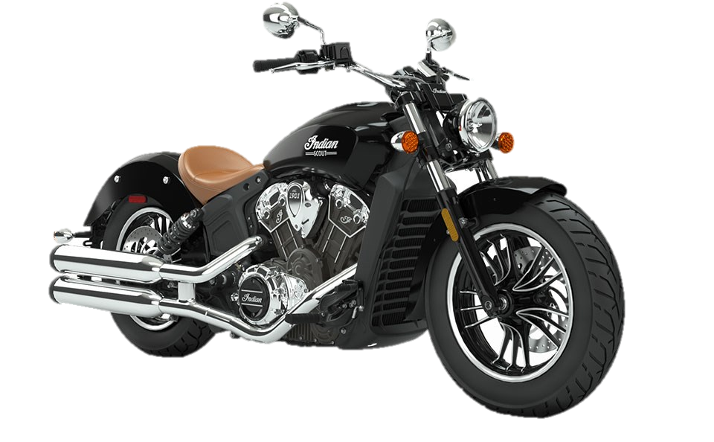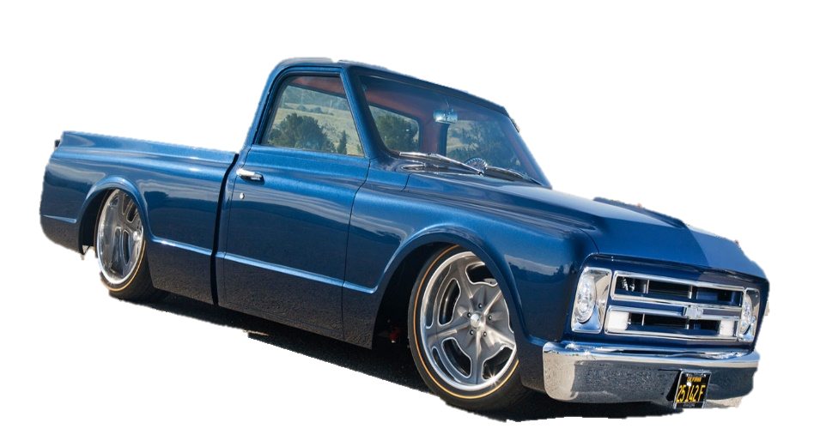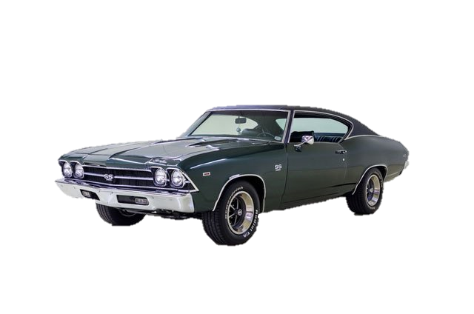

**ROSE BUD SUMMERFEST 2019**

**Open Car Show**

**SATURDAY, JUNE 22, 2019**

**9AM-3PM @ Ballpark Complex Behind School**

**Best Car, Truck, Rat Rod, Motorcycle, Corvette & Mayor’s Choice! Entry fee is donation basis. Trophies & Door prizes awarded at 3pm. Make plans to join us all weekend for carnival rides, fireworks, live music, free lunch, and plenty of games to celebrate Rose Bud’s 50th Year!**